**F4E signs Diagnostics Engineering Services contract**

[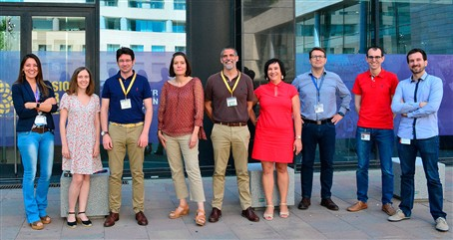](https://f4e.europa.eu/Downloads/News/07_Samina_diagnostics_web-190720191200-Large.jpg)

F4E and AVS representatives meeting at F4E Barcelona

F4E's Diagnostics Project Team has signed the contract for the provision of manufacturing engineering support for the Diagnostics systems (F4E-OFC-0905) with engineering company [AVS](http://www.a-v-s.es/) (Spain). The signing follows the [information meeting](https://f4e.europa.eu/mediacorner/eventsview.aspx?content=1236) held last year for potential tenders from all over Europe.

While the design of F4E's Diagnostics contribution is being conducted under Framework Partnership Agreements with European Fusion Laboratories (EFLs), specific expertise in engineering for manufacturing will be provided by a single team of experts from AVS during the whole design phase. Diagnostics Systems and European Fusion Laboratories developing Diagnostics, have very particular needs and challenges requiring complex knowledge, hence manufacturing engineering support from industry with technical competences in many different fields of expertise is required in order to ensure the designs of the different Diagnostic systems meet the manufacturing requirements and can be manufactured within cost and schedule. AVS is an experienced industrial engineering company with expertise in manufacturing of complex and challenging equipments for Big Scientific Facilities (worldwide), with the technical capabilities required to supplement/complement the manufacturing engineering works performed by the EFLs. "As we are now approaching the finalisation of the preliminary design phase for most of the Diagnostics systems it makes sense to bring on-board European industrial companies to complement the work done by the EFLs. AVS engineering experts have the technical competences to evaluate if the designs that are being produced can be manufactured within cost and schedule baselines and be compliant with the ITER requirements. Specifically, AVS will assess the on-going Diagnostics design works in terms of manufacturing feasibility, cost and risks whilst providing accordingly expert guidance to F4E and EFLs", explains Sandra Julià Torres, technical responsible for the framework with AVS on behalf of F4E. "AVS is committed to bringing its unique heritage and providing support to F4E's Diagnostic Systems and the EFLs. After having successfully delivered countless turnkey projects such as accelerators, astrophysics, neutron sources, space and synchrotron main facilities, we are excited to help F4E and the EFLs to bring fusion a step closer*",*says José Miguel Carmona, Head of Fusion and Beams Area at AVS.